Appendix B – Right of Way and Survey

Right-of-Way

Right of Way contact for the project: Br#017C02 Deschutes Co.

- Right of Way is required if “Yes” to any of the following:

  - Possible Fee and/or Permanent Easement (PE) Acquisitions and/or Temporary Easement (TE) Acquisitions: Yes No
The estimated area involved:
    - For Fee: # Acres: or # Square Feet:
    - For PE: # Acres: or # Square Feet:
    - For TE: # Acres: or # Square Feet: 2,500

  - Possible Temporary Easements (TE) for:
Construction Yes No
Demolition Yes No
Access Yes No
Other Yes No

    - The number and type of potential right of way acquisitions:
#Total Files: 2
# Simple Acquisitions: 2
# Complex Acquisitions:
# *Residential Relocations:
# *Business Relocations:
# *Hardship Acquisitions
# Railroad Acquisitions :
# Government Acquisitions: 1

  - Possible Right of Entry’s will be needed for:
Access Yes No
Drilling Yes No
Environmental Survey Yes No
Other Yes No

- Are there Land Services considerations such as:
- Frontage Roads
  - Existing Yes No
  - Proposed Yes No
- Access Roads Yes No
- Cattle or Equipment Passes Yes No
- Major irrigation installations Yes No
- Other Yes No

- Are there known property owner concerns? Yes No
If yes, discuss details:

Other Right of Way Comments, Concerns or Considerations: This project is anticipated to require two temporary easements. One TE will be need from Tumalo Irrigation District on the north side of the bridge and one TE will be needed from the Hudson Family Trust. The acquisitions are not complex and should cost $10,000 each. Estimated R/W for the project is $20,000.
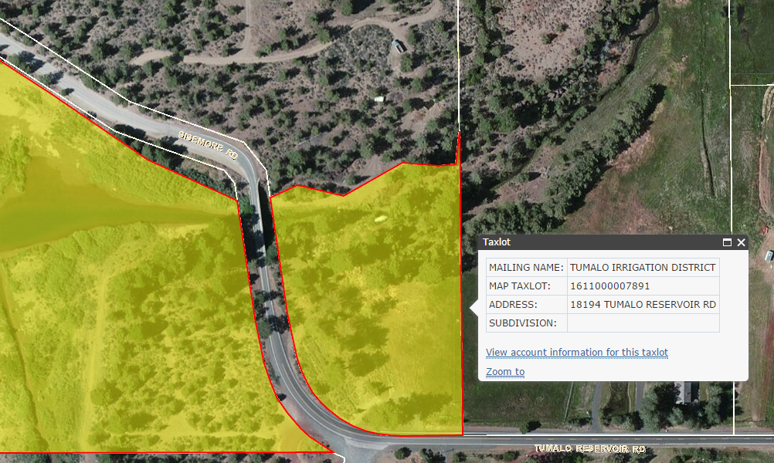

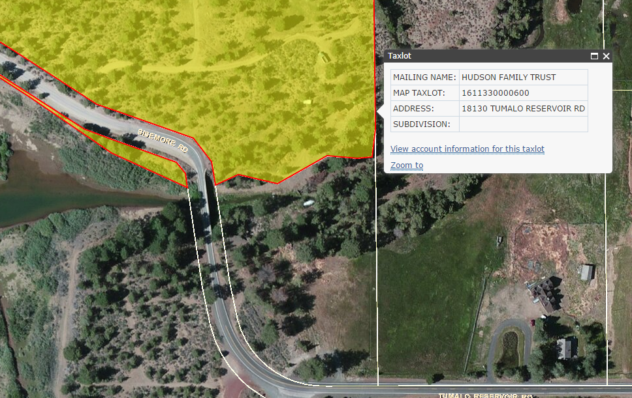

Survey

Aerial Photography: Proposed Not proposed Complete In progress

Field Survey: Proposed Not started Complete In progress

Has vertical and horizontal control been established on the ground? Yes No

Additional elements to be surveyed: (drainage channels, intersecting streets, buildings etc.)

